M04 Chapter 8 Hands On Projects
8-1
- Screenshot of ipconfig or Linux/Mac equivalent (step 4)
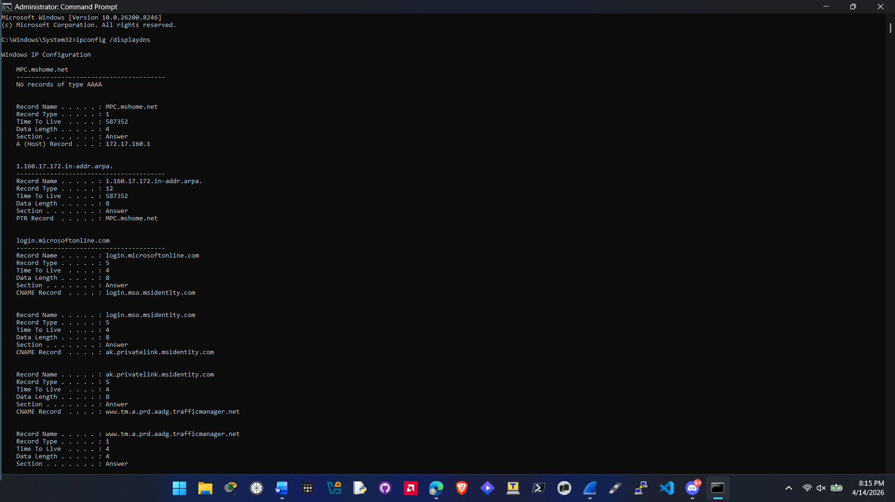
8-2 - do NOT forget to cancel (instead of apply/OK)
- Screenshot of the DNS tab settings (step 10)
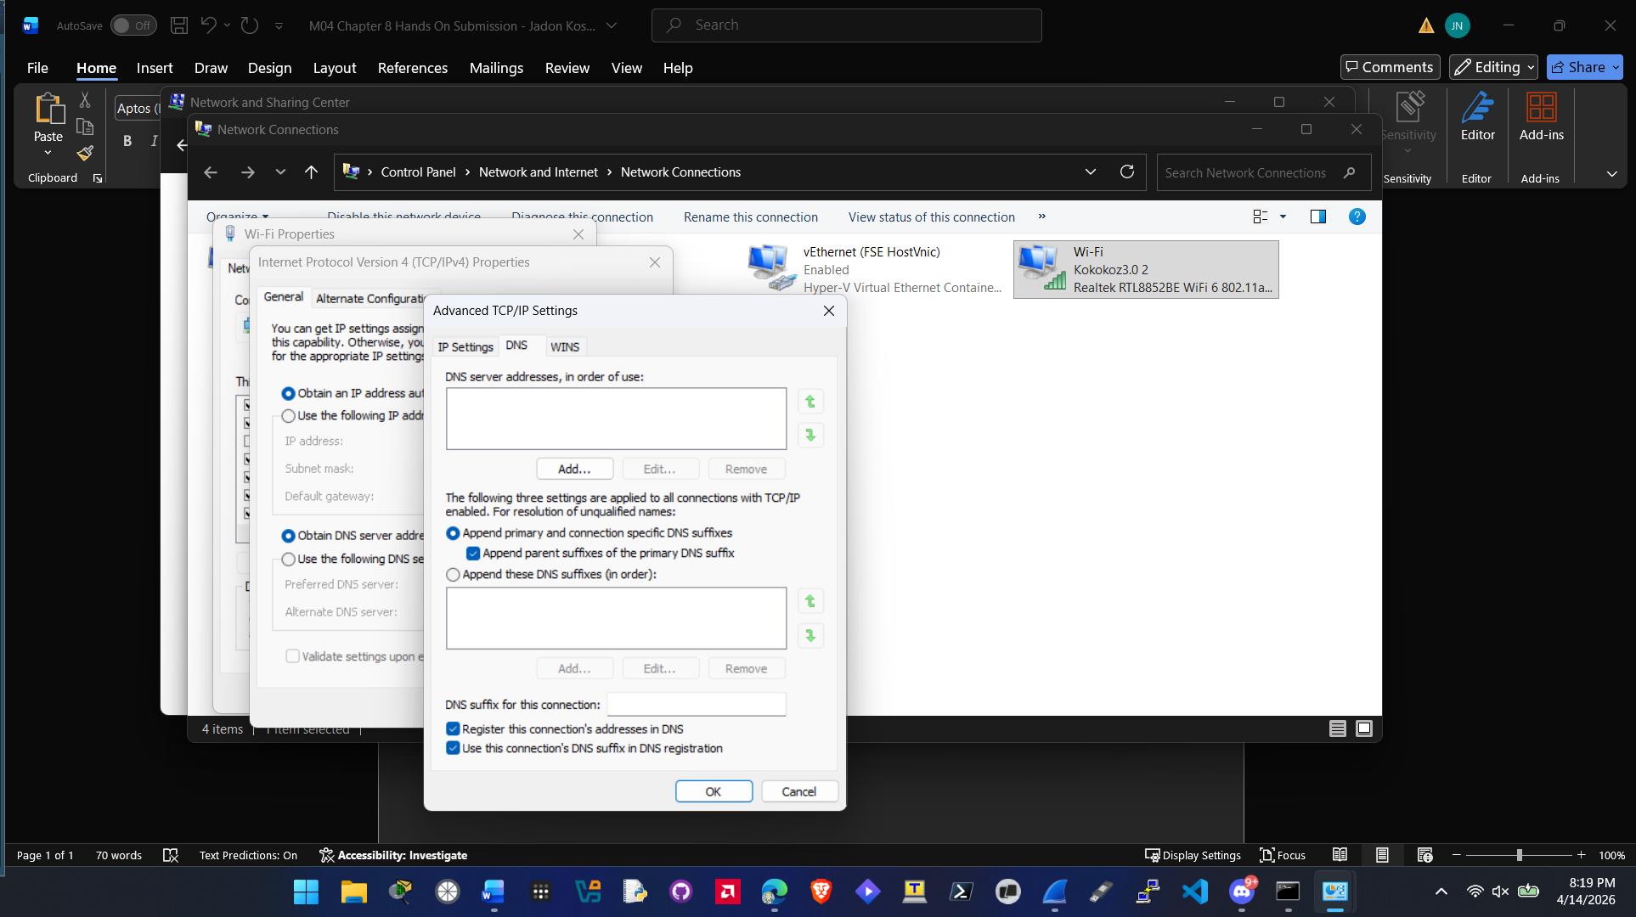
8-3 - if you do not have IPv6, use the IPv6 address for Google, which is 2607:f8b0:4009:819::200e
- Screenshot of the IPV6 literal output showing the IP address conversion
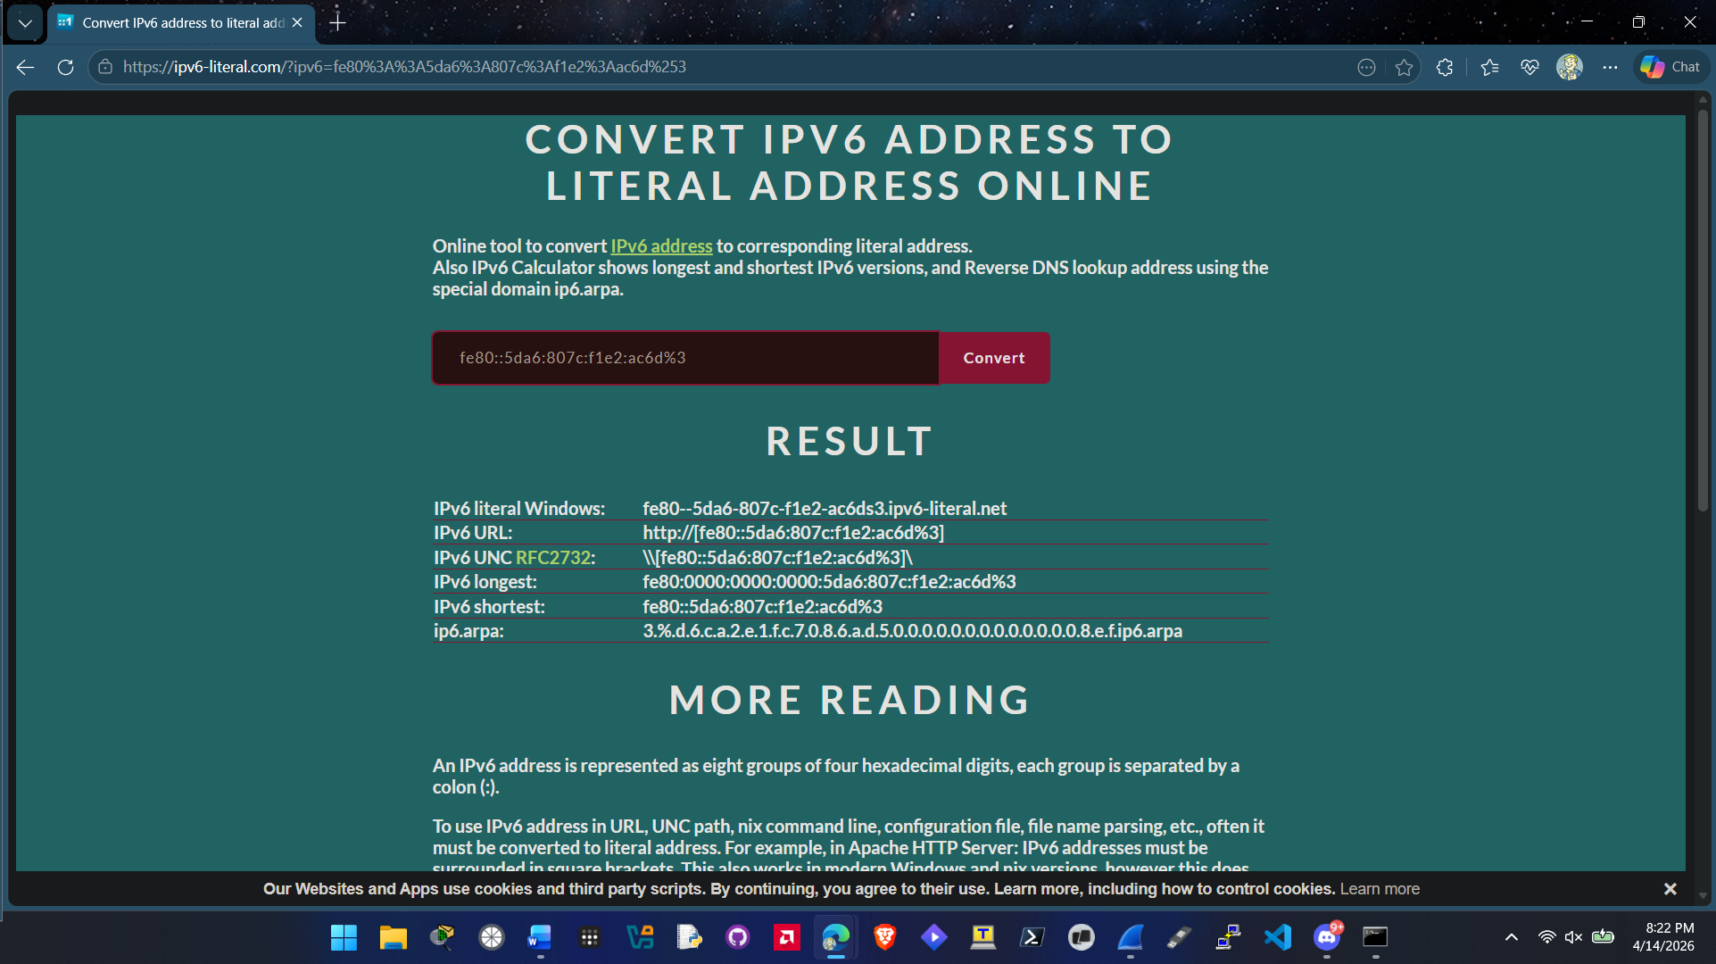
8-4
- Screenshot showing a DNS query expanded (step 11)
